4. What purpose do the forward and backward horizontal connections serve? Explain and provide a concrete example.
Simply put, the horizontal connections going forwards and backwards represent the input and output of a System Sequence Diagram. A simple example could be a user requesting information on an item from some system. The user interacts with the system by sending an input, and the output is generated by the system back to the user with useful information on the specified item (Satzinger et al., 2016, p. 140).
5. Draw a comprehensive Sequence diagram for full-time student registration at Mohawk College.
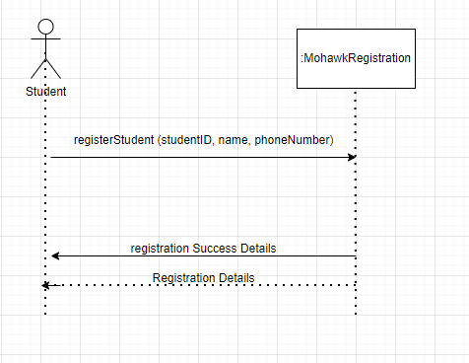

Satzinger, J. W., Jackson, R. B., & Burd, S. D. (2016). Systems analysis and design in a changing world
(7th ed.). Cengage Learning.

